# Pharmacy Sales Volume Prediction

|  |  |  |  |  |  |  |  |  |
| --- | --- | --- | --- | --- | --- | --- | --- | --- |
| ﻿Pharmacy | count | mean | std | min | 25% | 50% | 75% | max |
| 1 | XX | XX | XX | XX | XX | XX | XX | XX |
| 2 | XX | XX | XX | XX | XX | XX | XX | XX |
| 3 | XX | XX | XX | XX | XX | XX | XX | XX |
| 4 | XX | XX | XX | XX | XX | XX | XX | XX |
| 5 | XX | XX | XX | XX | XX | XX | XX | XX |
| 6 | XX | XX | XX | XX | XX | XX | XX | XX |

Task: use the data in the past 7 days to predict the sales in the coming 7 days.

We use only San Marcos for this round of development, just to make the model comparison easier. But the algorithms can be easily applied to others in the same way.

The output of the models are 7 predictions for the 7 days.

We use two methods:

# Method 1

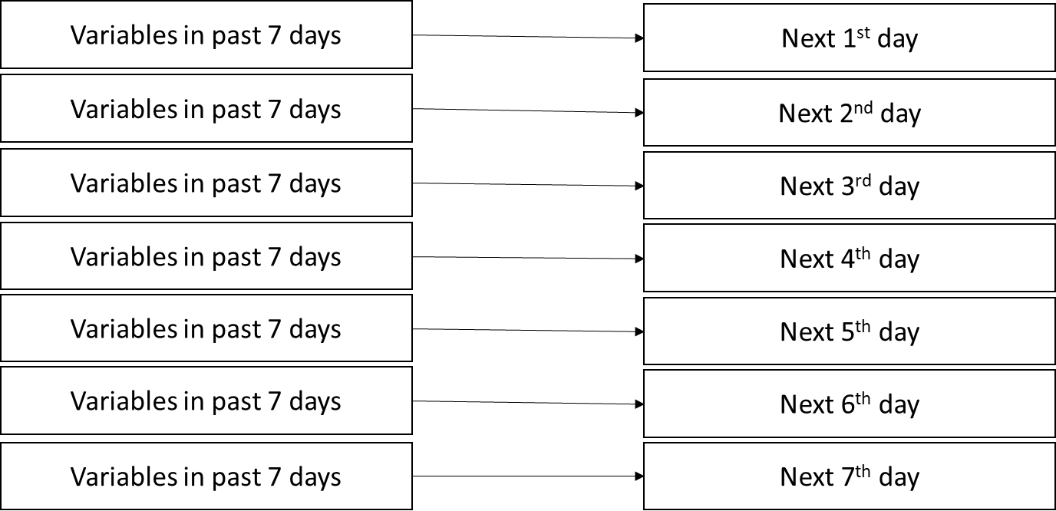

Results of Method 1

In this round, we used the four ML models: LinearRegression, DecisionTreeRegressor, BaggingRegressor, RandomForestRegressor.

|  |  |  |  |  |
| --- | --- | --- | --- | --- |
| ﻿ | linear | tree | bagging | random forest |
| 1 | XX | XX | XX | XX |
| 2 | XX | XX | XX | XX |
| 3 | XX | XX | XX | XX |
| 4 | XX | XX | XX | XX |
| 5 | XX | XX | XX | XX |
| 6 | XX | XX | XX | XX |
| 7 | XX | XX | XX | XX |

# Method 2

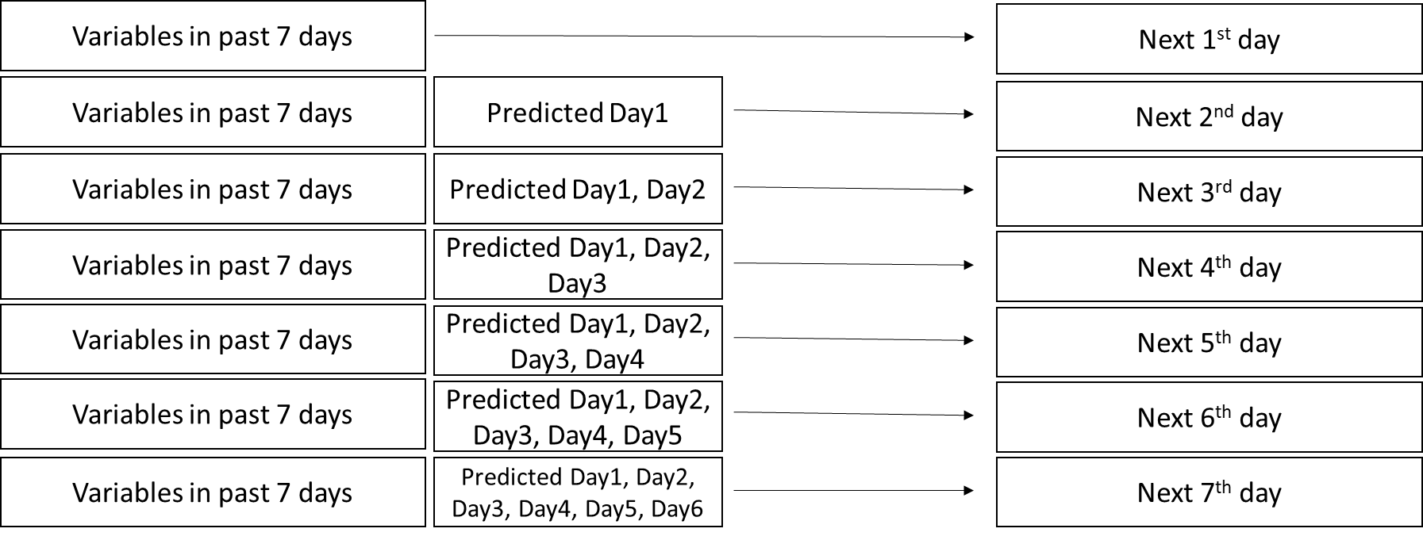

|  |  |  |  |  |
| --- | --- | --- | --- | --- |
| ﻿ | linear | tree | bagging | random forest |
| 1 | XX | XX | XX | XX |
| 2 | XX | XX | XX | XX |
| 3 | XX | XX | XX | XX |
| 4 | XX | XX | XX | XX |
| 5 | XX | XX | XX | XX |
| 6 | XX | XX | XX | XX |
| 7 | XX | XX | XX | XX |

# Demo

[I’ll show you how the models work during our meeting.]